Agenda- To send call to the Mobile for the request of the OTP

For this we need to first use the free website for the API

So I am using 2Factor In

<https://2factor.in/v3/?at_category=2factor&at_event_action=spr&service=BULK-SMS-OTP-SERVICE-PROVIDER>

so you can register in this and then navigate to the Account Summary where you will find your API key

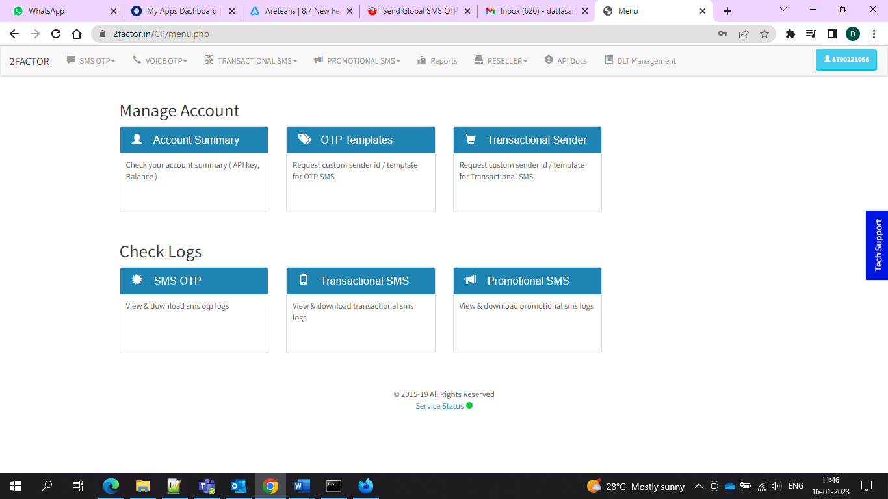

API Key would look like this

https://2factor.in/API/V1/:api_key/SMS/:phone_number/AUTOGEN

and now you need to replace it with your Api key and phone number and then you need to navigate to your App Studio. Create one Data type I created as Voice OTP and then we need to provide our URL and validate it and check the boxes for which you want to pass as a parameter.

In my case I am using the Phone number as a parameter since the API key is dynamic.

Below are the screenshots of the Configuration.

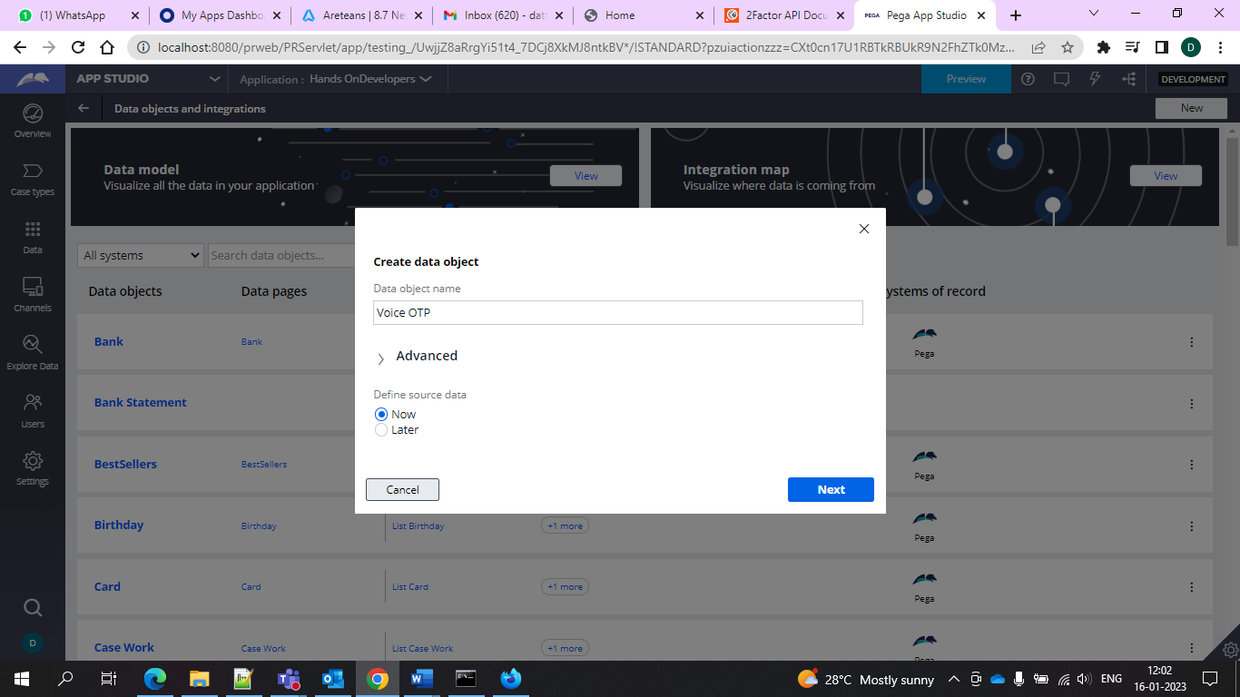

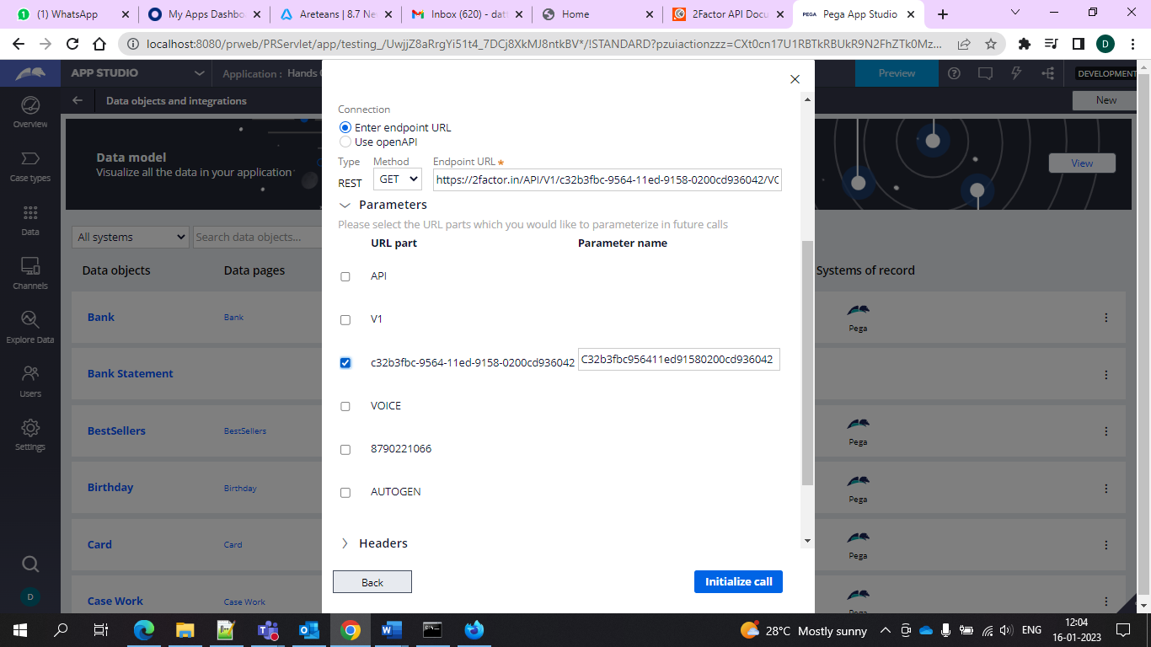

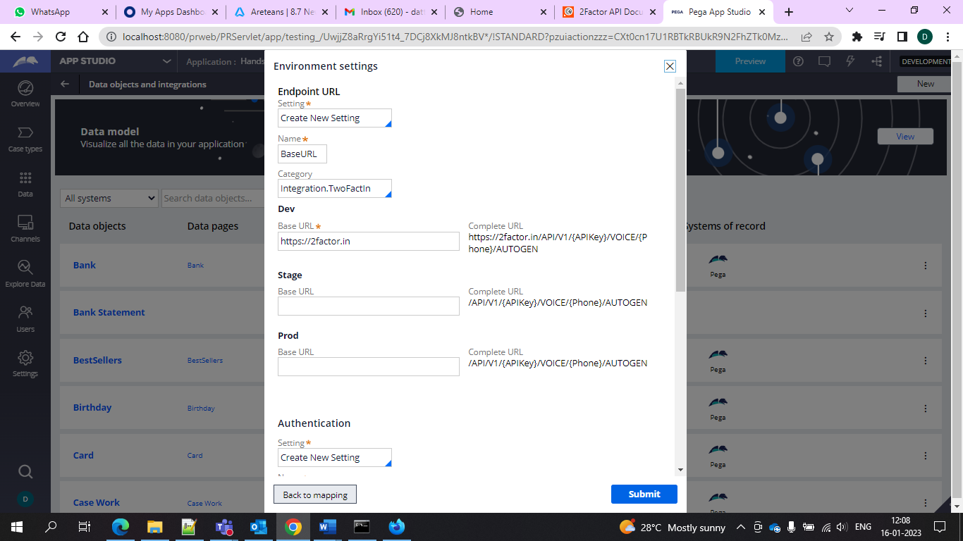

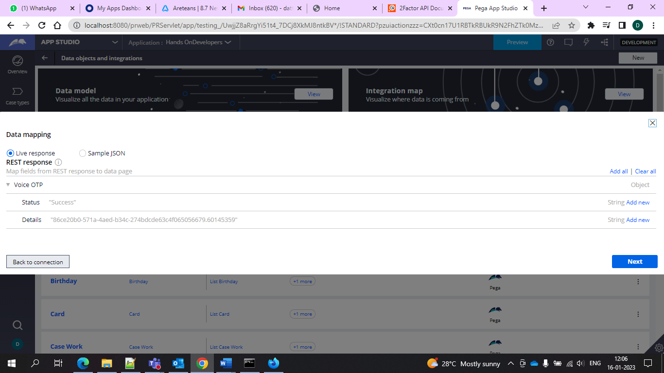

And after this creation we would be getting a call.

And if we want to pass multiple numbers we can navigate to the Dev Studio and run the data page associated with it and then run the data page and give your phone number as the parameter.

And done

